**Sensitive EQE Measurement Manual (last updated 2 Nov 2022)**

**Turn on:**

* Switch on extension cord
* Turn the light source and slowly move the dial to 90
  + Let the lamp warm up for approx. 20-30 mins
* Turn on the monochromator, the chopper and the Lock-In
  + If the chopper controller display reads 7777, turn it off and on again
  + Once the Lock-In is turned on and connected to a PC, you will hear clicking

**Setting Up:**

**Ubuntu Desktop**

* Type “ziService status” into the terminal
* If the answer is “ziServer has stopped”, then type “ziServer” into the terminal
  + The ziServer often crashes after a couple of minutes after the sEQE is turned on. If the sEQE control program crashes, then check the ziServer status again
  + **Do not close this terminal while using the instrument**
* Type “startWebServer” into a separate terminal, the command should auto-complete
  + You can now access the Lock-In control interface on <http://127.0.0.1:8006/> → click ‘open’
  + **Do not close this terminal while using the instrument**
* Start the sEQE Control Program by typing “cd Desktop/git/sEQE-Control-Software-master” and then “python3 sEQE.py”

**Windows Desktop**

* Start Windows computer and check that all cables are connected. Verify that monochromator is connected via a serial cable, not the USB cable.
* Log into your physics account and you should be able find Zurich Instruments LabOne and Anaconda Navigator on the desktop.

**If not:**

* + Install “LabOne” and the “MF device finder” from the Zurich instrument download center (https://www.zhinst.com/europe/en/support/ download-center) with admin rights (ask IT)
  + Create a virtual environment “sEQE” in Anaconda and install the needed python packages for the sEQE-control-software.
* Open “LabOne” software on the desktop. The Webserver opens automatically. If everything is correctly connected and installed, the Lock-in Amplifier should be found as device. Double click on the device to open the connection.
* Clone the sEQE-Control-Software code from <https://github.com/AFMD/sEQE-Control-Software>
* *(Deprecated) Open sEQE.py and find “platform.system() == 'Windows' “ section. Change “self.save_path = 'C:\\Users\\hanauske\\Desktop\\sEQE-Data' “ to “self.save_path = 'C:\\Users\\Your_Physics_Account_Name\\Desktop\\sEQE-Data' “. Save the file.*
* Open Anaconda and switch the environment from "root" to "sEQE" by left clicking on the "sEQE" name.
* Start “sEQE” environment in terminal.
* To run the sEQE script:
  + Navigating with "cd" commands towards the folder where you placed the "sEQE.py" file. Use “dir” command to see folder structure.
  + Type “python sEQE.py” into the terminal, press enter.
  + If you start the program the first time on your account, answer questions in terminal (without quotation marks):

1. Zurich instrument device ID, for AFMD: “hf2-dev838”

2. Port number of second filter wheel, for AFMD: “4”

3. Port number of monochromator, for AFMD: “1”

4. Save data path, for AFMD: “C:\\Users\\Public\\Documents\\sEQE”

These data will be saved in 'pathsNdevices_config.txt' and reloaded if this file is found.

* + Leave the terminal open during measurement. Avoid marking text in the terminal later or the software will be paused!!

**In the sEQE-Control-Software program**

* Go to second tab. Add the username, experiment name, and file name
* Press the connect button and check whether the monochromator, the filter wheel, and the Lock-In connection could be established.
  + If one or all are unsuccessful, connect to instruments individually by clicking the relevant buttons
* The Lock-In will probably be overloaded. You can tell that this is the case if the right lamp on the left-hand side of the Lock-In is on. If that is the case, go to the first tab of the program and click on the “Update parameters” button in the Lock-in section
* Place the sample in the holder.
* Go to the set-up. Check that the default position of the wheel filter is position 1, i.e. closed. If that is not the case, move to position one by hand and close and restart the program
* Move to filter position 2 in the software and a visible wavelength (500 nm works well) for alignment. If your samples absorb poorly, click “connect to monochromator” to have white light for re-alignment.
* Connect alligator clips to GND and whatever device you want to measure.
* Align by eye and use the Lock-In control (LabOne) interface for fine alignment. To do this, navigate to the “Plotter” tab in LabOne interface
  + Use the knobs on the sample stage to adjust the position of the substrate
* **Calibration:** System is relatively stable, and calibration is not required on each day of measuring. Calibration prior to critical measurements is recommended. (Temporary) The calibration files will be stored in sEQE/username you set for your reference scans
  + A calibration file is not needed for the measurement itself, but later on in the analysis tool. (During the measurement you will see raw data that need to be converted to EQE in the analysis tool)
  + The diodes are now connected in the CBD shown below. It can be placed into the sample holder as devices.
  + Calibration scans use a different connection method from devices. Connect the pins for diodes with the following fork alligator clips and connect the fork alligator clips to BNC wire labelled as ‘2’ leading to ‘+ In’ on Lock in Ampilfier (Don’t use ‘1’). Leave the other BNC wire freely and not touching metals.
  + The Si photodiode connects to pins J10 and J7(J6) with an amplification of 1000. The calibrated wavelength range for Si diode is 360-1100 nm.
  + The InGaAs photodiode connects to pins J3 and J7(J6) with an amplification of 1000. The calibrated wavelength range for InGaAs diode is 800-1500 nm.

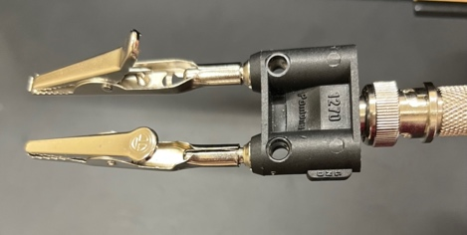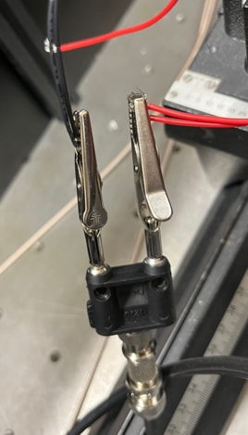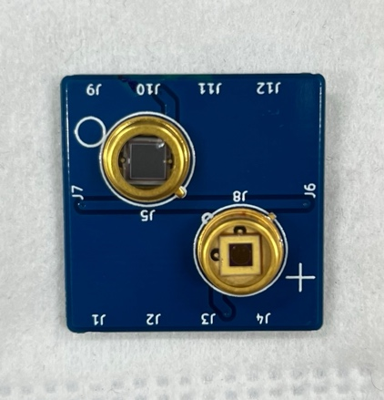

ßSi

InGaAsà

**Measurement**

* Once aligned, you are ok to start measuring: Preferably use the ‘Complete Scan’ Tab
* Select suitable filters to increase sensitivity in weak absorption regime
  + for ZnPc:C60 the following filter set works well: noFilter, 665nm, 715nm, 780nm; for lower band gap systems consider adding 850nm
* Adjust the step size (default 5 nm) , amplification etc. as needed
  + typically default amplification of 10^5 gives good results; consider higher amplification in the very weak absorption regime
* Files will automatically be saved
* The graph should update during measurement (Not yet for Windows)
* The time constant, data transfer rate and low pass filter order are set on page 1
  + The software averages 5 * time constant per value
  + In general, you do not need to change the data transfer rate and the low pass filter order.
* After each set of measurements has ended, the Thorlab filter wheel needs to be reset to 1 manually. This always needs to be done. Anna is working on making this process automatic.

**End of measurements**

* Once you are done with your measurements you need to switch off the monochromator, the chopper, and the lock in amplifier.
  + Turn down the light power source dial to zero and wait ~20 min for the lamp to cool down before switching it off.
  + Remember to also turn off the extension switch.
* Close all the terminals before leaving.
* Happily analyze your data!

**Monochromator filters**

Filter 1: closed

Filter 2: open

Filters 3 - 5: Optical filters that the program automatically moves to

**Thorlabs filter wheel filters**

Filter 1: open

Filters 2 - 5: Optical filters that the program automatically moves to

Troubleshooting

* Low signal even in strong absorption regime. May occur after a heavy overload (e.g. from setting a high amplification). Further diagnostics: recorded currents (see measurement files) are below 10^-6 to 10^-9.  
  → restart terminal server (close window, check status to make sure it has stopped, start again)
* No light beam
  + Set monochromator to e.g. 500nm
  + Set monochromator filter to 2 (=open, potentially manually)
  + Set Thorlabs filter wheel to 1 (=open, buttons at filter wheel)
* At low signals, Dip in the signal before saturating to slightly higher value → best guess: exchange cables OR exchange BNC to banana adapter